
3D Visualisation of Satellite Imagery
Design Report 3
Team Imagery
Damian Brockie
Rowan James
Shane Kingston
Matthew McKellar-Spence
Dafydd Williams

Contents
Scenarios 3
Use Case 6: User Invokes Shortcut Key 4
Use Case 15: User Defines ROI 7
Use Case 18: User Saves ROI 10
Use Case 19: User Loads ROI 13
Use Case 27: User Invokes Feature Space View 15
Use Case 30: User Scales Feature Space 17
Use Case 33: User Selects ROI Colour 19
Use Case 34: User Selects Feature space Points 22
Use Case 37: User Performs Channel Operations 25
Use Case 40: User Operates Filter 29
OO Diagrams 32
Package Diagram 33
Class Diagrams 34
Prototype Report 39
Contrast Stretch / Brightness Window 40
Preferences Window 47
ROI Creation Window 50
Feature Space Creation Window 59
Feature Space Window 65
Release Schedule 71
Release 1 72
Release 2 73
Release 3 75
Text File Report 76
ROI Definition File 77

3D Visualisation of Satellite Imagery
Scenarios
Team Imagery
Damian Brockie
Rowan James
Shane Kingston
Matthew McKellar-Spence
Dafydd Williams

Use Case 6: User Invokes Shortcut Key

Requirement
There shall be global keyboard shortcuts for several common operations (zoom, pan, apply filter, etc.)

Overview
This scenario describes the process of handling shortcut keys.

Preconditions
1. The Parbat3D program is running.
2. At least one window (main utility) must be open.
3. The window in which the shortcut applies to must currently have the keyboard focus.

Scenario
Action | Software Reaction
1. The user presses one of the zoom in or out shortcut keys while the image window or overview window is focused. | 1. The software zooms the image in or out by one step depending on the key pressed.  2. The image and overview windows are updated.
2. The user presses one of the pan shortcut keys while the image window or overview window is focused. | 1. The software pans the image up, left, right, or down depending on the key pressed.  2. The image and overview windows are updated.
3. The user presses the apply filter, or define ROI shortcut keys while the image window or overview window is focused. | 1. The software performs the action required as described in the appropriate scenarios, depending on which key is pressed.
4. The user presses the tool window’s tab switching shortcut key while the tool window is focused. | 1. The software changes the currently active tab on the tool window to the next tab in the order of left to right.
5. The user presses the tool window shortcut key | 1. If the tool window is hidden the software makes the window visible.  2. If the tool window is not currently active, it is made active and moved to the front of the screen.
6. The user presses the image window shortcut key | 1. If the image window is hidden and an image is loaded, the image window is made visible.  2. If the image window is not currently active and an image is loaded, it is made active and moved to the front of the screen.
7. The user presses the feature space window shortcut key | 1. If one feature space window has been created the software will make sure it is visible, active and in front of all other windows.  3. If multiple feature space windows have been created, the software will make one of them visible, active and in the foreground. The window will be selected depending on the last one that was active, in way that allows pressing the key multiple times to select each feature space window in order.
8. The user presses the help shortcut key | 1. A web browser will be launched containing the programs main help page.
9. The user presses one of the zoom in or out shortcut keys while the image window or feature space window is focused. | 1. The software zooms the feature space in or out depending on which key was pressed.  2. The software updates the feature space display.
10. The user presses one of the pan shortcut keys while the feature space window is focused. | 1. The software pans the feature space up, left, down or right depending on which key was pressed.  2. The software updates the feature space display.
11. The user presses one of the rotate shortcut keys while the feature space window is focused. | 1. The software rotates the feature space horizontally or vertically depending on which key was pressed.  2. The software updates the feature space display.
12. The user presses one of the granularity shortcut keys while the feature space window is focused. | 1. The software increases or decreases the granularity depending on the key pressed.  2. The software updates the feature space display.

Scenario Notes
- All actions can occur at any time while the associated window is displayed and currently focused.

Post Conditions
1. The action which is associated with the shortcut key is performed as it would if it was executed by the user in the longer way.

Required Views (GUIs)
1. Main Overview Window
2. Image Window

Exceptions
None

Use Cases Utilised
UC15_User_Defines_ROI
UC40_User_Operates_Filter

Timing Constraints:
None

Annotations:
Q: Should there be a shortcut key for switching between tabs in the tools window?
A: Possibly. It has been added.

Q: Should there be a shortcut key for opening up a feature space view?
A: Yes, I have added it.

Q: Should there be a shortcut key for opening an image?
A: Yes, it has been added.

Q: Should there be a shortcut key for the help file (f1 perhaps)?
A: Yes, it has been added.

Q: Should there be a shortcut key for increasing and decreasing the Granularity ration?
A: Possibly. It has been added.

Q: Should there be a shortcut keys for panning, zooming and rotating feature space?
A: Yes, it has been added.

Use Case 15: User Defines ROI

Requirement
The user shall be able to define ROIs by selecting areas of the image with the mouse

Overview
This scenario describes the process of defining the Regions of Interest within the image using the mouse and giving those ROIs names.

Preconditions
1. The Parbat3D program is running.
2. At least one window (main utility) must be open.
3. An image must be loaded.
4. The tool window must be displayed with the ROI section visible.
5. The image window must be displayed before an ROI can be defined.

Scenario
Action | Software Reaction
1. The user clicks on the new ROI button within the ROI toolbar. | 1. The new ROI button within the ROI toolbar will remain in the pushed in position.  2. A message is displayed telling the user to click on the image to define the points of the ROI  3. The mouse cursor is changed within the image window.
2. The user clicks the left button of the mouse on the image window, away from any previously defined point for the new ROI. | 1. The location of the image under the mouse cursor is recorded.  2. A square is drawn over the image at the position of the mouse cursor.  3. If a point has already been defined, a line will be drawn from the last point that was defined to this new point.
3. The user clicks the left button of the mouse on the image window near the first point that was defined for the new ROI. | 1. The location of the image under the mouse cursor is recorded as the final point of the ROI.  2. A line is drawn from the last point that was defined to this final point.  3. The newly defined ROI is added to the list of ROIs with a default name and colour.  4. The new ROI button that was previously in the pushed in position is now released to its normal state.
4. The user clicks on the define new ROI button within the ROI toolbar, or presses the escape key, after the define new ROI button has already been pushed in. | 1. The squares and lines showing the previously defined points are removed from the image display.  2. The previously defined points are removed from memory.  3. The new ROI button that was in its pushed position is now released to its normal state.
5. The user double clicks on the name of a ROI within the list of ROIs. | 1. An edit box appears around the name within the ROI list allowing the name to be edited by the user.
6. The user presses enter while editing the name of the ROI. | 1. The name of the ROI is updated to whatever is contained within the edit box.
7. The user presses escape while editing the name of the ROI, or clicks outside of the edit box. | 1. The content of the edit box is ignored. The name of the ROI remains the same as it was before the user began editing it.

Scenario Notes
- Actions 2, 3 & 4 can only occur after Action 1.
- Action 2 may occur multiple times.
- Either Action 3 or 4 can occur while defining an ROI, but once one of them occurs the other will not.
- Actions 6 & 7 can only occur after Action 5.
- Either Action 6 or 7 can occur while editing a name, but once one of them occurs, the other will not occur.

Post Conditions
1. A ROI will be added to the ROI list with a default, or user-defined, name and default colour only if an area was correctly defined with the first point connecting to the final point.

Required Views (GUIs)
1. Main Interface
2. ROI section of the Tool Window
3. Image Window

Exceptions
None

Use Cases Utilised
None

Timing Constraints:
None

Annotations:
Q: Should one of the preconditions be that an image is loaded?
A: Yes, have added it.

Q: Should a scenario not be that either 3 or 4 can be done but not both and that either 6 or 7 can be done but not both?
A: Yes probably. They have been added.

Q: Should one of the required views be the image window because the ROIs are edited within it?
A: Yes. It has been added.

Q: Should part of the scenario be about defining a new colour for the ROI?
A: It was included originally but it has its own separate use case/scenario, so I don’t think it needs to be mentioned here.

Q: Action 1, Software reaction 1 - Does the user hold the button in, or is there feedback in the form of the button staying in a pressed position?
A: Feedback in form of button staying in a pressed position. It has been made clearer.

Q: Can the user press delete to remove a point if he clicks the wrong spot?
A:

Q: Action 3 - Should the user click the very first defined point to close the loop and finish the ROI?
A: Yes. It has been modified.

Q: Is the ROI given a default name when it is first created or is the user prompted to select a name and choose location to save?
A: It is given a default name.

Use Case 18: User Saves ROI

Requirement
ROIs shall be able to be saved to disk

Overview
This scenario describes the process of saving ROIs to a file.

Preconditions
1. The Parbat3D program is running.
2. An ROI has been Defined.

Scenario
Action | Software Reaction
1. User selects at least one ROI in the ROI list. | 1. ‘Save’ button on the ROI tab in the Tools window becomes active.
2. User deselects or removes all ROIs in the ROI list. | 1. The ‘Save’ button on the ROI tab in the Tools window becomes disabled.
3. User selects ‘Save’ button from the ROI tab on the Tools window or file menu item. | 1. The Main GUI is disabled.  2. User is presented with the default Windows Operating System Save Options window.  3. The default filename is set to the name of one of the selected ROIs.
4. User selects disk location. | 1. The file path is displayed.
5. User re-names ROI if default name is not desired. | 1. Default name is overwritten.
6. User selects save button on the Save Options window. | 1. The ROI is saved to the selected location with the given name and control is returned to the main GUI.  2. If file already exists, user is prompted with overwrite file options window.
7. User selects Cancel button on Save options window. | 1. The Save Options window disappears.  2. Control is returned to Main GUI.
8. User selects Cancel from overwrite file options window. | 1. Overwrite file options window disappears.  2. Control is returned to Save options window.
9. User selects Overwrite from overwrite file options window. | 1. The existing file is overwritten.  2. Save Options window and Overwrite options window both disappear.  3. Control is returned to Main GUI

Scenario Notes
- Action 1 can occur at any time.
- Action 2 can occur only after action 1.
- Action 3 can only occur after action 1 and before action 2.
- Actions 4 & 5 can occur in any order and only after action 3 and are optional.
- Action 6 can occur after action 3, 4 or 5.
- Action 7 can occur after action 3, 4 or 5.
- Action 8 can occur only after action 6 with software Reaction 2.
- Action 8 can occur only after action 6 with software Reaction 2.

Post Conditions
1. The currently selected ROIs are saved to disk in a single file.
2. If action is cancelled, the ROI will not be saved.

Required Views (GUIs)
1. Image Window
2. ROI selection Window

Exceptions
1. If the file could not be saved due to a file permission error, or if the file is already being used by another program, the user will be presented with the windows default error.
2. If the disk runs out of space, the user will be presented with the windows default error.

Use Cases Utilised
Follows on from Use Case 15: User Defines ROI.

Timing Constraints:
The image should be saved as quickly as possible.

Annotations:
Q: Where does the user click to select an ROI?
A: Have changed to state, this Scenario follows on from the Scenario for Use Case 15: User Defines ROI. ROI is saved immediately after being defined.

Q: Where is the “Save ROI” button?
A: On the ROI tab in the tools window. Have added to Scenario.

Q: Are there any changes to window states after this use case?
A: ‘Save ROI’ is greyed out. ‘New ROI’ is made active. Have added to Scenario.

Q: Will there be any times when an ROI cannot be saved?
A: When one is not created. Have added detail to Scenario to state, Save button only becomes active after ROI has been defined.

Q: The overview window is not mentioned in the scenario so is it needed as a required view?
A: No. Have removed.

Q: Should the scenario mention that scenario actions 5.3, 6, 7 and 8 are final steps (scenario doesn’t continue) and they cannot happen together?
A: Anywhere in ‘software reactions’ that says control is returned to main GUI is where the scenario ends. Have made amendments to clarify.

Q: Should the post conditions be changed to take into account when a user clicks cancel (ROI will not be saved or updated on the disk)?
A: Yes. Have amended.

Use Case 19: User Loads ROI

Requirement
ROIs shall be able to be loaded from disk

Overview
This scenario describes how the user can load Regions of Interests (ROIs) from a file.

Preconditions
1. The Parbat3D program is running.
2. At least one window (main utility) must be open.
3. The image that the ROIs belong to must be loaded.

Scenario
Action | Software Reaction
1. User clicks load button in ROI toolbar or selects load from menu | 1. Open load dialog box
2. User selects file and clicks open | 1. Load file  2. Translate file contents into ROI storage format  3. Update ROI list with ROIs  4. Update image window with ROIs

Scenario Notes
- The ROI window must be opened for the load button to be pressed

Post Conditions
1. ROIs have been loaded and added to the ROI list.

Required Views (GUIs)
1. Main (overview) window
2. Load dialog box

Exceptions
1. If the ROI does not belong to the image an error message will be shown and the loading process will be rolled back.
2. If changes to the current ROI have been made a dialog box will appear asking the user if they want to continue loading. If they click yes, the loading continues and changes are lost. If they click no, the loading stops and changes are preserved.
3. If the ROI file is incorrectly formatted or otherwise unable to be parsed an error box will pop up to inform the user and this loading will be cancelled.

Use Cases Utilised
None

Timing Constraints:
File must be opened and contents loaded without slowing workflow.

Annotations:
Q: Should the software update the screen (list of ROIs & image window (if open) & maybe even feature space (if open))?
A: Yes, updated software reactions and scenario notes

Q: Should an error message be displayed if the ROI belongs to another file?
A: Yes, an exception has been added

Q: Should the software check if any changes have been made to the current ROI list before loading the file and loosing the changes?
A: Yes, an exception has been added

Q: Should Action 2, Software Reaction 2’s last word be “format”, as opposed to “form”?
A: Yes, this has been fixed.

Q: What happens if the ROI file is incorrectly formatted or otherwise unable to be parsed?
A: An error box will be shown and the action cancelled. An exception has been added.

Q: Should “Region of Interests” be “Regions of Interest”?
A: Yes, this has been fixed.

Use Case 27: User Invokes Feature Space View

Requirement
The application shall display in two or three dimensions a scatter plot of the pixels values from the spectral bands selected by the user

Overview
This scenario describes how the feature space window can be opened by the user. The window will contain a scatter plot based on selected pixel values. The pixels may be specified by Regions of Interest.

Preconditions
1. The Parbat3D program is running.
2. At least one window (main utility) must be open.
3. An image is loaded
4. Pixel values have been selected by the user

Scenario
Action | Software Reaction
1. The user clicks the feature space tab on the tools window. | 1. The feature space creation controls are displayed in the tool window.
2. The user selects areas to be displayed (whole image, or ROIs), bands to be used for each axis and the granularity for the feature space. | 1. Image areas are stored in memory  2. Image bands are stored in memory  3. The granularity setting is stored in memory
3. The user initiates the feature space view by clicking the ‘Generate’ button | 1. Create and display a new feature space window based on the chosen image areas, bands and granularity.  2. Draw a scatter plot of the pixels within the feature space window

Scenario Notes
None

Post Conditions
1. A feature space window is displayed
2. A scatter plot of the pixels is displayed in the newly created feature space window

Required Views (GUIs)
1. Main (overview) window
2. Tools window
3. Feature space window

Exceptions
None

Use Cases Utilised
None

Timing Constraints:
The feature space should be displayed in a reasonable amount of time.

Annotations:
Q: Should the user be able to select what image bands they want to display as the X, Y & Z variables?
A: Yes, scenario has been changed to reflect this

Q: Should you mention how the user selects the area to display? (also possibly different for different areas – eg. User may want to select one or more ROIs, or the whole image, etc. as the “area”)
A: Yes, scenario has been changed to reflect this

Q: Should you mention how the user initiates the feature space view? (eg. By button, or menu, etc.)
A: Yes, scenario has been changed to reflect this

Q: Can the user select an initial granularity ratio, or is the scatter plot created with a default value that can be changed later?
A: A default value will be given that can be changed before the plot is created and then this value can be changed in the window, updating the scatter plot. Scenario has been updated.

Q: Can the user associate colours with selected ROIs in the scatter plot?
A: Yes, this will default to the colour set to the ROI already but may be changed before the window is created. Scenario has been updated.

Use Case 30: User Scales Feature Space

Requirement
The feature space shall be able to scale the granularity of the pixel data, from a 1:1 ratio of one pixel per point in the scatter plot, and thereafter one point in the feature space may represent a number of pixels in the image.

Overview
This scenario describes how a user will define the granularity for a Scatter Plot and Update it.

Preconditions
1. The Parbat3D program is running.
2. The Feature Space Creation window in the Tools tab is displayed.

Scenario
Action | Software Reaction
1. User moves the granularity slider on the Feature Space Creation tab in the Tools window. | 1. The new granularity ratio is set.  2. The number of pixels that will be generated in the Scatter Plot with the chosen granularity setting is calculated and displayed near the slider.
2. User creates the Scatter Plot as described in the scenario for UC27: User Invokes Feature Space View. | 1. The Scatter Plot is created with the chosen granularity setting.

Scenario Notes
- Action 1 can occur at any time.
- Action 2 can occur without action 1 occurring and the default value will be used.

Post Conditions
1. The Scatter Plot in the Feature Space window is displayed with the preset granularity.

Required Views (GUIs)
1. Feature Space Creation window in the tools tab.

Exceptions
None

Use Cases Utilised
UC27: User Invokes Feature Space View.

Timing Constraints:
The Scatter Plot should be updated as quickly as possible.

Annotations:
Q: Does the Feature Space Control window need to be open for scaling if the user scales the feature space with a keyboard shortcut or the mouse wheel?
A: No, have removed.

Q: In the scenario notes, it says action 2 can only happen after action 1. But couldn’t the user hit update without changing the values? If so, should there be an exception or appropriate software reaction for this?
A: Nothing will happen if the update buttons is pressed without the value being changed.

Q: The overview window doesn’t seem to be in this scenario, is it needed as a required view?
** meant to say “doesn’t seem to be used in this scenario”, do we need it as a required view?
A: It’s the first one listed under ‘Required Views’!
** program won’t run without the Overview window, but it isn’t needed for the operation of this function. Have removed now

Q: Which tool window does the “Granularity” slider appear in? The scenario specifies “the tool window”, but which one?
A: Feature Space Creation tab in the Tools window. Have amended.

Q: The scenario notes that Action 2 can only occur after Action 1, but Action 1 can be performed without adjusting granularity first (ie. a default value is used). Correct or incorrect?
A: Correct. Have amended.

Q: Assuming the Feature Space Creation tool window/tab is the GUI that the granularity control is associated with, should this then be listed under required GUIs, and also as a precondition?
A: Yes. Have amended.

Use Case 33: User Selects ROI Colour

Requirement
Colours defined for the ROI in the main image window shall be mirrored by those pixels in the feature space.

Overview
This scenario describes selecting a colour for a previously defined ROI.

Preconditions
1. The Parbat3D program is running.
2. At least one window (main utility) must be open.
3. The ROI window must be open.

Scenario
Action | Software Reaction
1. The user double clicks on a colour box next to the name of a ROI within the list of ROIs. | 1. A system colour picker dialog box will be displayed allowing the user to select a colour.
2. The user successfully chooses a new colour from the colour picker dialog box. | 1. The points and lines on the image window which define the ROI will be changed to the selected colour.  2. The colour box next to the name of the ROI in the ROI list will be updated to show the new colour.
3. The user cancels the colour picker dialog box, or selects the original colour. | 1. The software will ignore the chosen colour and use the last chosen, or default colour for the ROI.
4. The user double clicks on the default ROI colour box in the preferences window. | 1. A system colour picker dialog box will be displayed allowing the user to select a colour.
5. The user cancels the colour picker dialog box, or selects the original colour. | 1. The software will ignore the chosen colour and keep the previous default colour.
6. The user successfully chooses a default colour from the colour picker dialog box. | 1. The software will record the new default colour.
7. The user sets the default colour to ‘random’ in the preferences window. | 1. The default colour option will be recorded.
8. The user creates an ROI as per scenario for UC15: User Defines ROI. | 1. If the default colour has been set the new ROI will be set to that colour. If ‘random’ has been selected as the default colour, the software will choose a colour for the ROI.

Scenario Notes
- Action 1 can occur anytime when at least one ROI exists in the ROI list.
- Either action 2 or 3 will occur after action 1.
- Action 4 can occur anytime when the preference window is displayed.
- Either action 5 or 6 will occur after action 4.

Post Conditions
1. The points and/or lines that define the ROI on the image window will be shown in the chosen colour.
2. The colour box shown next to the name of the ROI in the ROI list will be shown in the chosen colour.
3. If the colour selection process was cancelled by the user the ROI’s colour box and points and/or lines will remain in the original colour.

Required Views (GUIs)
1. Main Interface
2. ROI section of the Tool Window
3. Image Window
4. 3D Feature Space
5. Preferences

Exceptions
None

Use Cases Utilised
None

Timing Constraints:
The software should update the image and feature displays to reflect the new colour as quickly as possible.

Annotations:
Q: Does an ROI need to be selected? What happens if one is not created or selected?
A: ROI is now selected when colour drop-down box is clicked.

Q: Is there a limit to the number of custom colours a user can create?
A: Yes, but there will be a wide range. The user will be able to select any colour that is present on the system colour palette.

Q: Will the user be able to define the same colour for multiple ROIs?
A: Yes – they may want to for some reason (eg. To make areas with similar land the same colour). I don’t think we need to restrict it.

Q: Can the user define the default colour?
A: It has been added.

Q: Should the user be able to define a random colour as the default, so each time a new ROI is created it has a different colour?
A: Yes, has been added.

Q: Will the system still update everything if the user selects the same colour that the ROI already has?
A: No, has been updated.

Q: Should there be a post condition for if the user chooses cancel instead, like the system is returned to its previous state?
A: Yes, has been added.

Use Case 34: User Selects Feature space Points

Requirement
The user shall be able to select the points in the feature space interactively.

Overview
This scenario describes the user selecting points in the Feature Space window, which in turn highlights the corresponding pixels in the Image Window.

Preconditions
1. The Parbat3D program is running.
2. At least one window (main utility) must be open.
3. The Image Window must be open.
4. A Feature Space must have been created, and must be the foremost window.

Scenario
Action | Software Reaction
1. The user clicks on an unselected point in the Feature Space. | 1. The point has its colour changed to a preset distinguishing colour.  2. Any pixels in the Image Window that correspond to the value represented by that point will also be highlighted in a preset distinguishing colour.
2. The user clicks on a selected point in the Feature Space. | 1. The point is returned to its original colour.  2. Any pixels in the Image Window that correspond to the value represented by that point be un-highlighted.
3. The user drags a “lasso” around a group of points. | 1. Any previously unselected point has its colour changed to a preset distinguishing colour.  2. Any pixels in the Image Window that correspond to the value represented by the selected points will also be highlighted in a preset distinguishing colour.
4. The user drags a “lasso” around a group of points, while holding the Shift key. | 1. Any previously selected point inside the lasso has its colour returned to its original colour.  2. Any pixels in the Image Window that correspond to the values represented by those same points will be un-highlighted.
5. The user presses the ESC key. | 1. Any previously selected points will be deselected.

Scenario Notes
- Actions 1, 3 and 4 can occur at any time, although Action 4 will not do anything if no points have been selected.
- Action 2 can only occur after Actions 1 or 3, or after an Action 4 in which some points remain selected.
- If a point scale of other than 1:1 is currently in effect, all pixels represented by a point will be selected.
- If a point selected represents pixels not currently being viewed in the Image window, those pixels will be highlighted if the user scrolls the Image window.

Post Conditions
1. Pixels in the Image Window and points in the Feature Space may be highlighted.

Required Views (GUIs)
1. Main Interface
2. Image Window
3. Feature Space

Exceptions
1. If there are no points in a Feature Space, no points can be selected.
2. Only points in the current Feature Space will be selected.

Use Cases Utilised
UC27 User Invokes Feature Space View

Timing Constraints:
None

Annotations:
Q: Will there be different shapes that can be used to select points, such as a square, as well as the lasso?
A: No.

Q: Will there be a way of cancelling all the selected points quickly, such as by clicking the ESC key?
A: Yes, hitting the Escape key will do this. Adjusted scenario to match.

Q: If more than one feature space window is open, will points selected in one be highlighted in another?
A: No, only points in the current feature space will be selected.

Q: If selected points do not appear across feature spaces, what happens if points are selected in one and different points are selected in another? Will there be different highlight colours for different feature spaces?
A: If you swap Feature Spaces, point selections will be lost. Points can only be selected in the current Feature Space.

Q: Should there be something mentioning what happens if the point (or points) selected in the feature space is (are) currently off screen? Would they are highlighted when they come on screen by the user panning or zooming out?
A: Yes, they would. This would be handled by the Image window.

Q: Step 1, Software Reaction 1 - Is the point already coloured in a preset distinguishing colour or does it become coloured as a reaction to step 1 (Also Step 3, Software Reaction 1)? ‘is’ or ‘becomes’?
A: Closer to “becomes”, yes; have changed them both to “has its colour changed to”, to try and avoid ambiguity.

Q: Step 4, Software Reaction 1 - Any ‘selected points’ or ‘preselected points’? Is shift and lasso drag meant to be a deselecting tool for pre selected points?
A: I’ve now changed it to “previously selected”. Shift-lasso is indeed meant to be a deselecting tool, and have changed its wording as well.

Use Case 37: User Performs Channel Operations

Requirement
Common operations such as normalizing and contrast enhancement (stretches) shall be embedded into the channel management system.

Overview
This scenario describes filtering operations on the three monitor display channels. The two operations are “brightness” and “contrast”. Additional controls provide for manual adjustment of the black, white and grey points.

Preconditions
1. The Parbat3D program is running.
2. At least one window (main utility) must be open.
3. An image must be loaded.
4. The image window must be open.

Scenario
Action | Software Reaction
1. The user selects “Contrast Stretch” from the “Tools” menu. | 1. The user is presented with a new dialogue box, as per GUI prototype “contrast”.
2. The user toggles the “Preview” checkbox button. | 1. A “Preview” checkbox will be toggled as the user clicks on it.  2. The software sets itself into Preview mode or not, depending on the setting of this checkbox. This allows changes to be viewed dynamically in the Image Window. Changes will only be displayed in the Image Window if the “Preview” option is enabled.
3. The user moves the slider marked “Contrast”. | 1. The slider will move from its current position (default is middle at “50”) to anywhere between “0” and “100”.  2. The contrast of the image will be adjusted in increments of one unit as the slider moves along.  3. An indicator value will change to reflect the current position of the slider.
4. The user moves the slider marked “Brightness”. | 1. The slider will move from its current position (default is middle at “50”) to anywhere between “0” and “100”.  2. The brightness of the image will be adjusted in increments of one unit as the slider moves along.  3. An indicator value will change to reflect the current position of the slider.
5. The user toggles the “Advanced” checkbox button. | 1. An “Advanced” checkbox will be toggled as the user clicks on it.  3. If the “Contrast Stretch” window is currently in “Basic” mode, the “Advanced” adjustment tools will be displayed in the window. If it is in “Advanced” mode, the “Basic” tools will be displayed.
6. The user toggles the “Per channel adjustment” checkbox button. | 1. A “Per channel adjustment” checkbox will be toggled as the user clicks on it.  2. An additional two adjustment toolsets will be displayed in the window; either “Advanced” or “Basic” depending on the setting of the “Advanced” checkbox.
7. The user moves a black-point adjustment triangle in a given colour-point adjustment toolset. | 1. The triangle will move along the bottom of the histogram for the chosen colour-point adjustment toolset.  2. The value for the black-point will change to a value between 0 and 255, depending on user control.
8. The user moves a white-point adjustment triangle in a given colour-point adjustment toolset. | 1. The triangle will move along the bottom of the histogram for the chosen colour-point adjustment toolset.  2. The value for the white-point will change to a value between 0 and 255, depending on user control.
9. The user moves a grey-point adjustment triangle in a given colour-point adjustment toolset. | 1. The triangle will move along the bottom of the histogram for the chosen colour-point adjustment toolset.  2. The value for the grey-point will change to a value between 0 and 255, depending on user control.
10. The user enters a value in a black-point adjustment field for a given colour-point adjustment toolset. | 1. The triangle will move along the bottom of the histogram for the chosen colour-point adjustment toolset, to the position specified in the adjustment field.  2. The value for the black-point will change to a value between 0 and 255, depending on user control.
11. The user enters a value in a white-point adjustment field for a given colour-point adjustment toolset. | 1. The triangle will move along the bottom of the histogram for the chosen colour-point adjustment toolset, to the position specified in the adjustment field.  2. The value for the white-point will change to a value between 0 and 255, depending on user control.
12. The user enters a value in a grey-point adjustment field for a given colour-point adjustment toolset. | 1. The triangle will move along the bottom of the histogram for the chosen colour-point adjustment toolset, to the position specified in the adjustment field.  2. The value for the grey-point will change to a value between 0 and 255, depending on user control.
13. The user clicks the “Cancel” button. | 1. The “Channel Operations” window is closed.  2. No display changes are made to the image. If the “Preview” function was active, the Image Window returns to its original state.
14. The user clicks the “OK” button. | 1. The “Channel Operations” window is closed.  2. If the “Preview” function is enabled, the Image Window continues to display the adjusted channels.  3. If the “Preview” function was not enabled, the Image Window will display the results of the channel adjustment.

Scenario Notes
- Actions 2, 5, 13 and 14 can occur at any time.
- Actions 3 and 4 can only be performed when not in “Advanced” mode.
- Actions 6 through 12 can only be performed when in “Advanced” mode.

Post Conditions
1. The Image Window will display the results of any channel operations, if Action 14 was performed.
2. If Action 14 was not performed, the Image Window will not be affected.

Required Views (GUIs)
1. Main Interface
2. Image Window
3. Channel Operations Window

Exceptions
1. A white-point cannot be set to a lower value than its associated black-point or grey-point.
2. A black-point cannot be set to a higher value than its associated white-point or grey-point.
3. A grey-point cannot be set to a lower value than its associated black-point or a higher value than its associated white-point.
4. A typed in value for a black, white or grey point will be constrained to the bounds for Exceptions 1, 2 and 3, and, in addition, only values between 0 and 255 will be accepted.

Use Cases Utilised
None

Timing Constraints:
None

Annotations:
Q: For Reaction 2 in actions 3 & 4, should you say the image will only change if the preview checkbox is ticked?
A: Yes, I should. Changed.

Q: For action 5 should you say that the basic controls will be replaced with the advanced controls, or vice versa?
A: Yes, I should. Changed.

Q: For action 6 should you say that the basic controls will be replaced with the per channel adjustment controls, or vice versa?
A: Yes, I should. Changed.

Q: Should you mention the “Auto” buttons will be greyed out (or similar) when the values are currently set to the defaults?
A: I have removed the “Auto” feature, so this no longer applies.

Q: How does the user get back to basic mode from advanced mode?
A: By toggling the “Advanced” checkbox control. Have adjusted scenario to reflect this.

Use Case 40: User Operates Filter

Requirement
The application shall provide a means to stream (export) channel or image data to third-party filters designed for use with the application.

Overview
This scenario describes how the user can apply filters to an image. The filters will be plug-ins that can be created by third-parties. The data will be transferred by using streams to send the data to a filter and then get the data back from the filter after the effects have been applied.

Preconditions
1. The Parbat3D program is running.
2. At least one window (main utility) must be open.
3. An image must be open.
4. Parbat has the name and a description of at least one filter, and a way of accessing each filter available (a path).

Scenario
Action | Software Reaction
1. User chooses to apply a filter either from a menu option or a toolbar | 1. Open filter dialog box
2. User selects parameters for filter (type of filter, area affected, etc) and clicks apply | 1. Parbat sends the image data to the filter using the filter’s standard input  2. The filter applies its effects to the image data  3. The data is sent from the filter using the standard output  4. Parbat gets the data and updates the image
3. The user chooses cancel filter from the menu option or clicks a cancel button in the filter toolbar | 1. Parbat stops the filter  2. Any output from the filter is disregarded

Scenario Notes
- If cancel is clicked in the filter dialog box, the software reactions to 2 will not be carried out.
- If the filter requires any parameters, it will provide its own interface to set them. This may mean that a dialog box is created in between the data being sent and received.

Post Conditions
1. The image should have the filter applied, unless cancel was selected, then the system will be in the same state as it was before the filter was applied.

Required Views (GUIs)
1. Image window
2. Filter dialog box
3. Main (overview) window
4. Tools window

Exceptions
1. The selected filter does not exist.
2. The data returned from the filter is corrupted.
3. If the filter has an internal error the data will be discarded.

Use Cases Utilised
None

Timing Constraints:
None

Annotations:
Q: Will plug-ins need to provide some information to Parbat3D on their effects?
A: Yes, a name and description would need to be provided. A precondition has been added for this.

Q: Will Parbat3D allow for filters with controls? If so, will these be GUI controls or text-based input?
A: I assumed these would be part of the filter, so it would provide its own interface. Parbat should only have to worry about streaming data to it or getting data back from it. A scenario note has been added.

Q: Will a filter indicate success or failure in some way? What happens on filter failure?
A: Data will be discarded, an exception has been added.

Q: Will there be a list of available filters or will the user find the executable themselves?
A: Both, there is a list of filters that have been added and the user can add more filters to the list.

Q: If there is a list of available filters, will there be a way to add or move filters from the list (or menu, toolbar, etc)?
A: Yes, adding and removing would be handled in the preferences window.

Q: Will a progress bar or dialog box be shown while the filter is executing?
A: This will be the responsibility of the filter to give feedback.

Q: Will there be a way of cancelling the filter as it is executing (e.g. in case it turns the program into ice)?
A: Yes, a cancel option has been added to the scenario.

3D Visualisation of Satellite Imagery
OO Diagrams
Team Imagery
Damian Brockie
Rowan James
Shane Kingston
Matthew McKellar-Spence
Dafydd Williams

Package Diagram

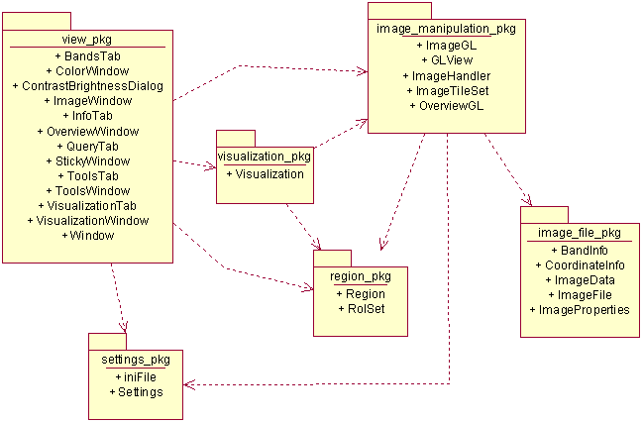

Class Diagrams

visualization_pkg

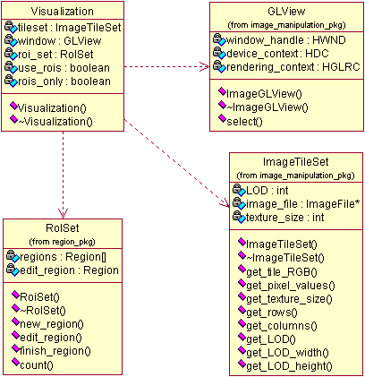

image_manipulation_pkg

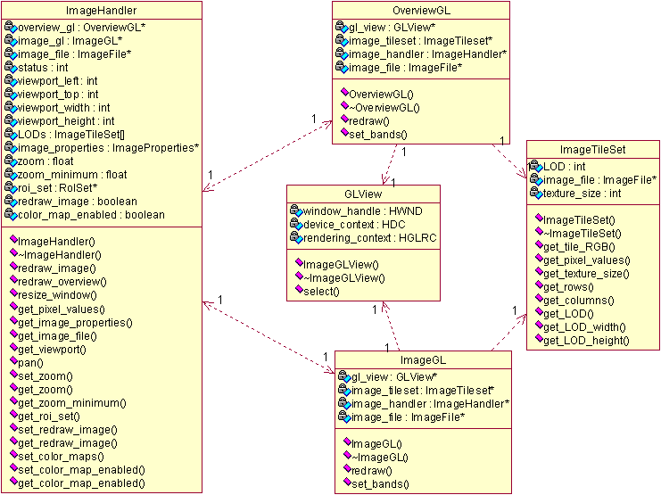

region_pkg

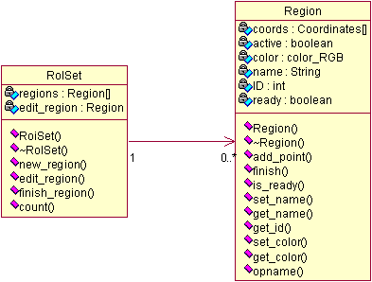

settings_pkg

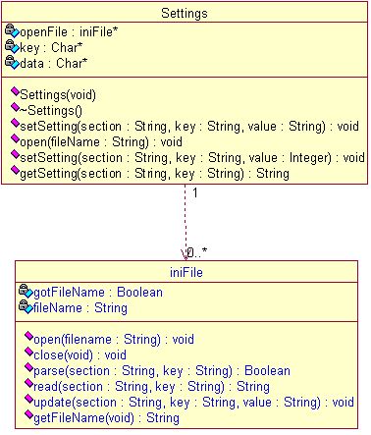

view_pkg

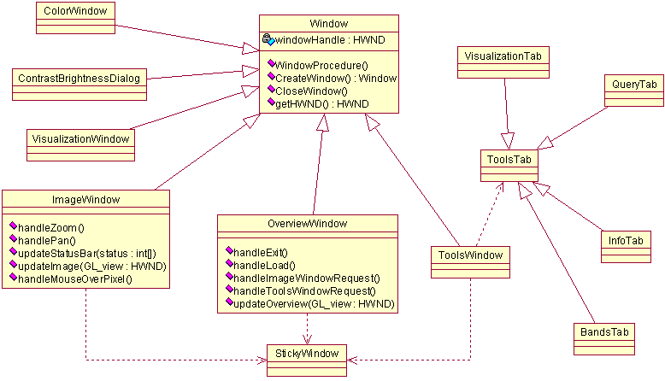

3D Visualisation of Satellite Imagery
Prototype Report
Team Imagery
Damian Brockie
Rowan James
Shane Kingston
Matthew McKellar-Spence
Dafydd Williams

Contrast Stretch / Brightness Window
The Contrast Stretch / Brightness Window is an interface for changing the appearance of the displayed image in the Image Window and is used to enhance the appearance only. It will not affect any data.
Stage 1

Description
- This prototype is accessed from the toolbar menu in the Overview window.
- The window on the left appears first and gives controls for the Brightness and contrast over the whole image.
- RGB colour range is the control for contrast stretch. Selecting ‘Manual’ and clicking ‘Edit Colour Range’, will bring up the window on the right.
- The window on the right displays a histogram for each channel with a slider for selecting the range.

Stage | Previous Stage | Developer
1 | None | Shane
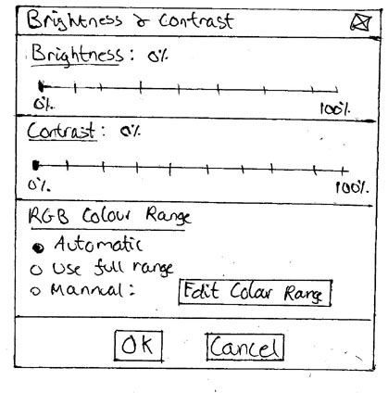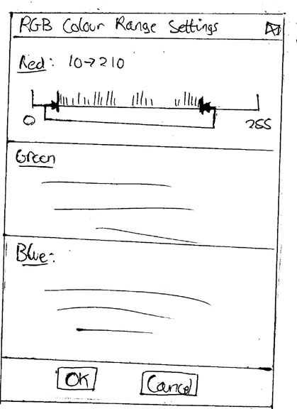

Feedback
Nil

Status
Another stage required
Stage 2

Description
- This prototype is accessed via the toolbar menu on the Overview window.
- It is based on the Photoshop style for the same operation.
- There are 2 options, 1 for adjusting a single channel or entire image and one for individually adjusting multiple channels.

Stage | Previous Stage | Developer
2 | None | Dave
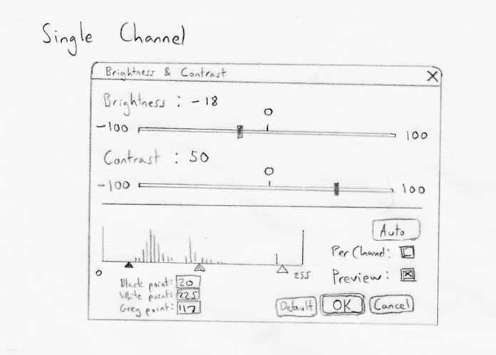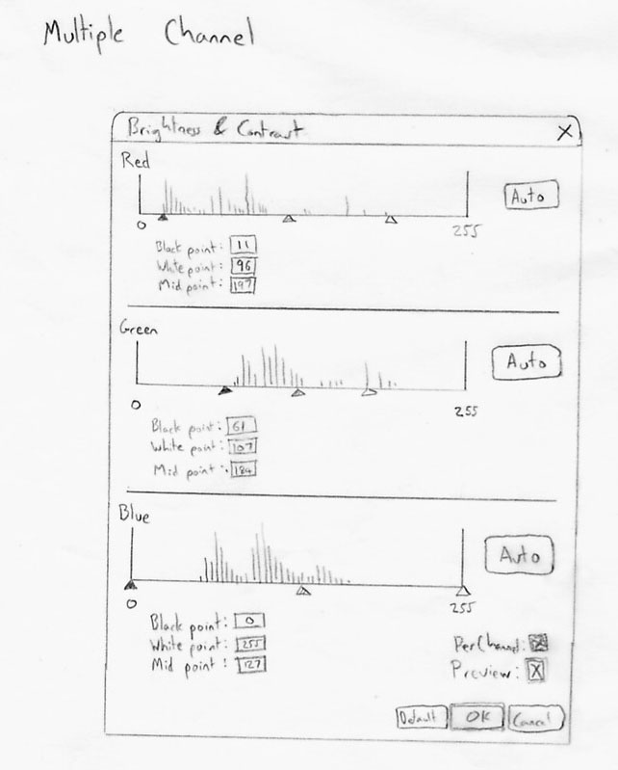

Feedback
Good
- I like the histogram
Improve
- How does one get from single to multiple channels? Perhaps an advanced/basic control button.
Francis Chui (Krill)

Good
- Providing the histogram style display is nice (although I presume the intended audience would know what it means).
- Default button is good, as is preview.
Improve
- How is auto different from defaults?
- The brightness/contrast numbers (-100, 100) mean what?
Michael Ford (BioDiv)

Status
Another stage required
Stage 3

Description
- This prototype is accessed via a tab in the Tools window.
- The user is first presented with a basic view for adjusting the brightness and contrast of the entire image.
- Upon selecting the Advanced button, the user presented with advanced options (right window). The user can then adjust the Brightness and Contrast individually for each displayed channel.

Stage | Previous Stage | Developer
3 | none | Damian
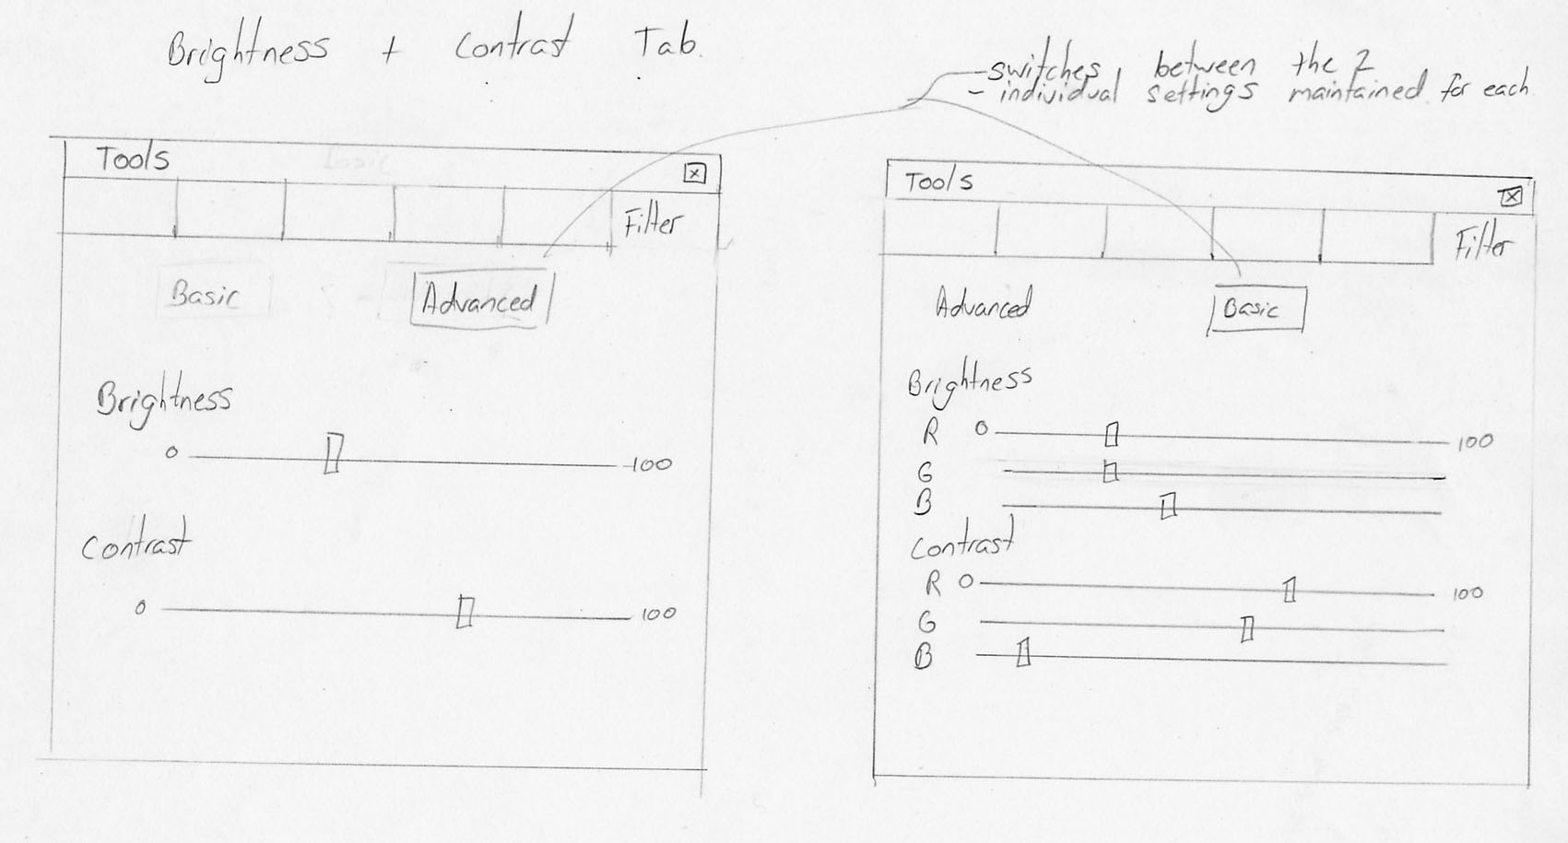

Feedback
Good
- Intuitive and basic with sliders. I like the ability to switch between RGB and all channels
Improve
- Buttons switching might get annoying.
- Maybe have one window and switching between basic/advanced will either lock or unlock the three channels.
- Could add a spinner/textbox for numerical input.
Francis Chui (Krill)

Good
- Having it as a separate tab is good
Improve
- How does changing RGB values change the overall values (if I changed values in 'advanced' and switch to 'basic' where would the slider be).
- What is the number 800, percentage?
- How about a defaults button?
Michael Ford (BioDiv)

Status
Another stage required
Stage 4

Description
- This prototype is accessed via the toolbar menu on the Overview window.
- The user is first presented with a basic ‘All Channels’ GUI for adjusting the brightness and contrast of the entire image.
- Upon selecting the ‘Per Channel’ checkbox, the user will be presented with a, per channel Options GUI (bottom window). The user can then adjust the Brightness and Contrast individually for each displayed channel.
- Having the Preview checkbox ticked, will update the image window on the fly.
- The Advanced checkbox will be implemented if time permits.

Stage | Previous Stage | Developer
4 | 1, 2 and 3 | Whole Team
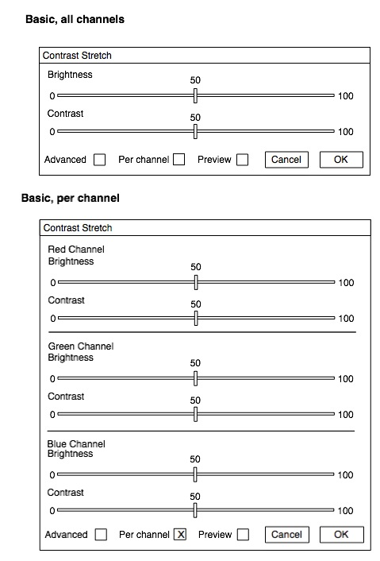

Feedback
Nil

Status
Approved by most people and finished

Preferences Window
The Preference window is for setting custom user settings such as, Memory Usage, Various incremental control settings, Display settings, shortcuts, default settings, etc.
Stage 1

Description
- This Prototype is a tabbed layout accessed from the toolbar menu in the Overview window.
- There are separate tabs for Memory Usage, Defaults and Shortcuts.

Stage | Previous Stage | Developer
1 | None | Shane
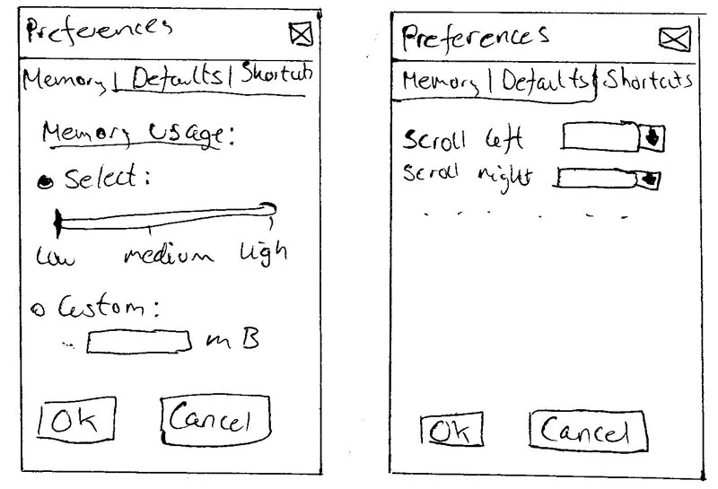

Feedback
Nil

Status
Another stage required
Stage 2

Description
- This Prototype is accessed via the toolbar menu on the Overview window.
- A tree structure is used to access different settings.
- Clicking on an item in the tree will highlight it and change the pane on the right to display the relevant options for those settings.

Stage | Previous Stage | Developer
2 | None | Matt
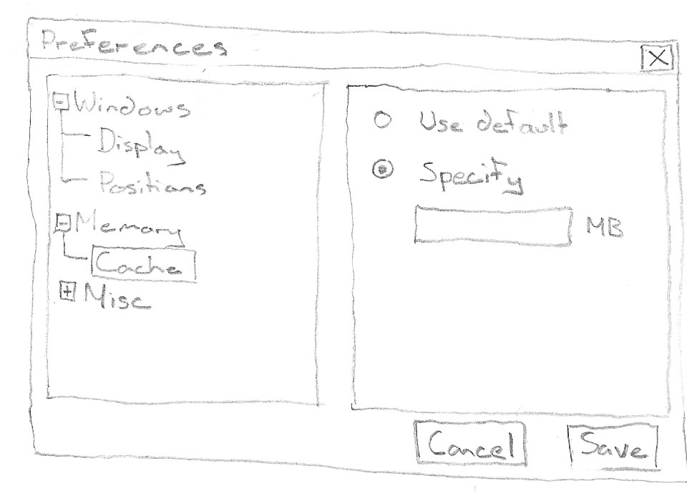

Feedback
Good
- Tree structure is good for the layout.
Improve
- A separate page displaying information on selected sections would help with usability.
Francis Chui (Krill)

Good
- Use tree menu
Kade Hylord (Krill)

Status
Another stage required
Stage 3

Description
- This Prototype will be accessed via the menu toolbar on the Overview window.
- A tree structure is used to access different settings.
- Clicking on an item in the tree will highlight it and change the pane on the right to display the relevant options for those settings.
- Items available in the tree structure will be:
  - Layout, which has default options selected via radio buttons.
  - Shortcut keys, for binding different keys to different shortcuts.
  - Memory Usage, will set how much memory Parbat will utilise.

Stage | Previous Stage | Developer
3 | 1 and 2 | Whole Team
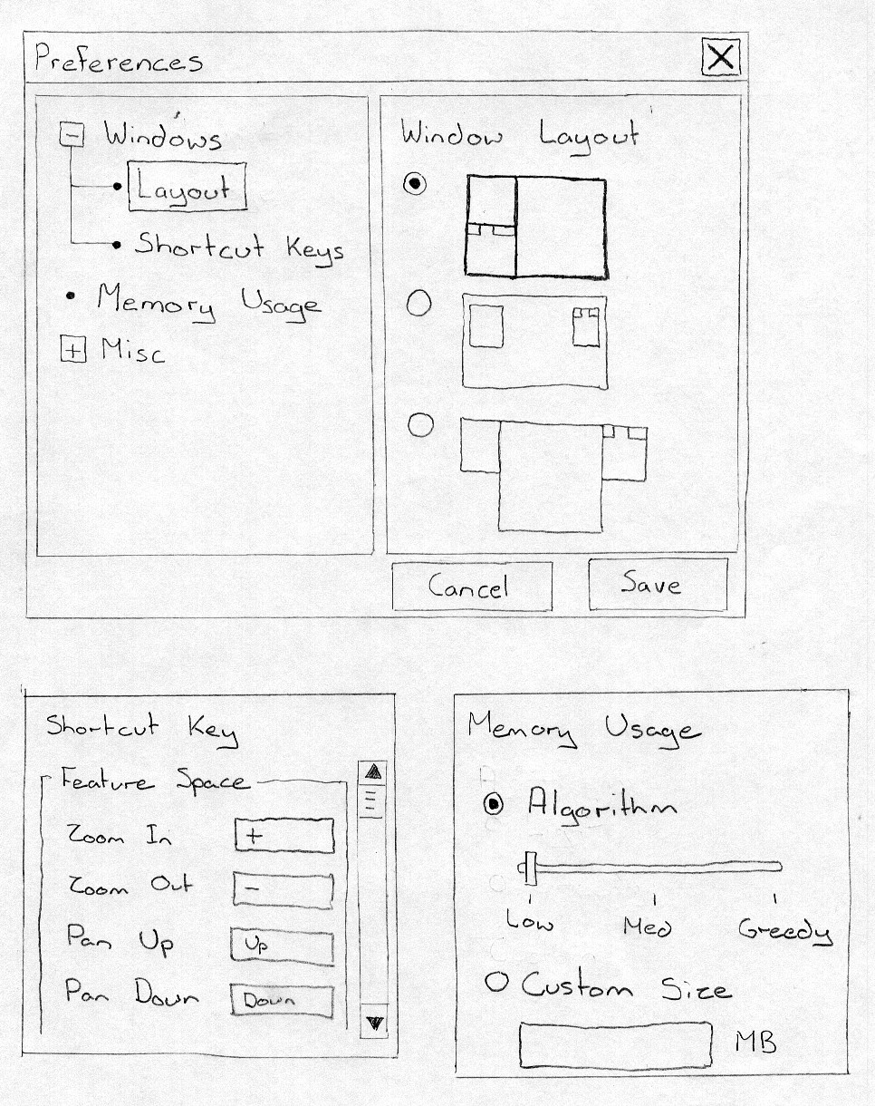

Feedback
Nil

Status
Approved by most people and finished

ROI Creation Window
The ROI creation Window is used to create, save, load and view Regions Of Interest (ROIs). ROIs will be able to have colours associated with them which will show in the Image window and in the Scatter Plot on the Feature Space window.
Stage 1

Description
- This Prototype is accessed via the Tools window.
- To define a new ROI, the ‘define new’ button is clicked and it will appear to be pushed in until an ROI has been created, or until the button is clicked again to cancel it.
- Everything else in the Tool window is disabled while the Define New button is pushed in.
- The user is prompted with instructions via the status bar.
- The user clicks on the image window to define points.
- When all points are connected, the ROI is added to the list & squares marking the points on the image window are removed.
- As the mouse is moved over the different controls (i.e. the buttons, ROI names, etc), tooltips are displayed in the status bar.
- The user double clicks on an ROI name to change it.

Stage | Previous Stage | Developer
1 | None | Shane
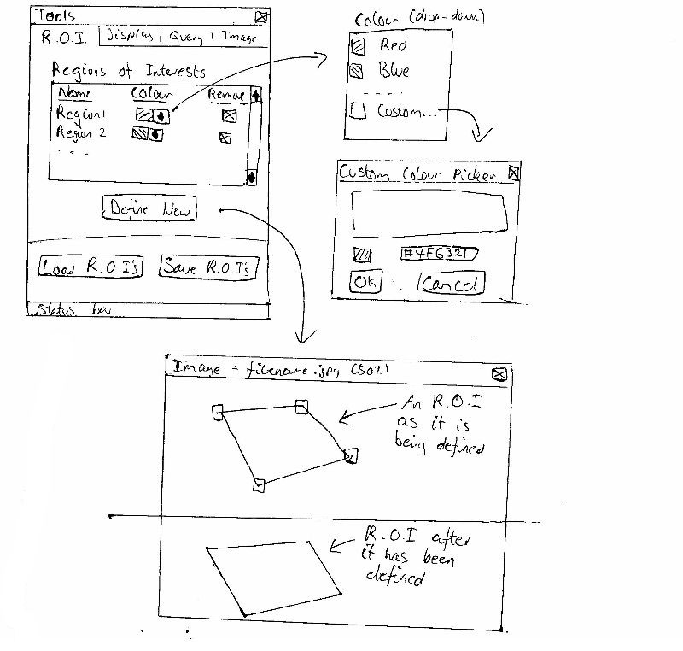

Feedback
Nil

Status
Another stage required
Stage 2

Description
- This prototype is accessed via the toolbar menu on the overview window.
- When a new region is created it is added to the list in the ROI window.
- A random colour is assigned to the ROI.
- Visibility of the ROI in the image window is controlled via the checkbox and is enabled by default.
- The colour assigned to the ROI is changed via a dialogue window after double clicking on the colour box.
- The ROI name can be changed by double clicking on it.
- The save button prompts the user to select a file to which selected ROIs can be saved (to our file format).
- The Load button prompts the user to select a file to merge with the current ROI list.
- The Trash button or the Delete key (after conformation) deletes selected ROIs from the list.
- The Black/White button inverts selection.
- Active ROIs are drawn translucently with their coloured lines in the Image window.
- Other 2 buttons enable creation of ROIs interactively as either rectangular or arbitrarily shaped polygons.
- Shift Key locks Polygonal creation tool to 15° snap.

Stage | Previous Stage | Developer
2 | None | Rowan
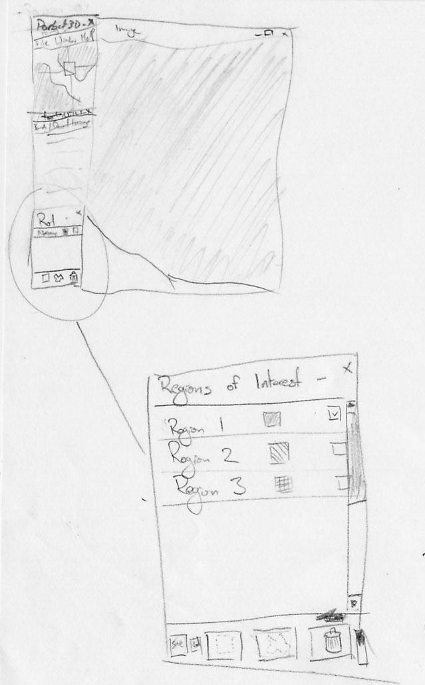

Feedback
Nil

Status
Another stage required
Stage 3

Description
- This prototype for ROI creation utilises a toolbar that is snapped to the image window.
- It can be toggled on and off via the toolbar menu on the Overview window.
- The loaded or created ROIs are accessed via a dropdown menu.
- ROIs can be loaded or created using buttons.

Stage | Previous Stage | Developer
3 | None | Matt
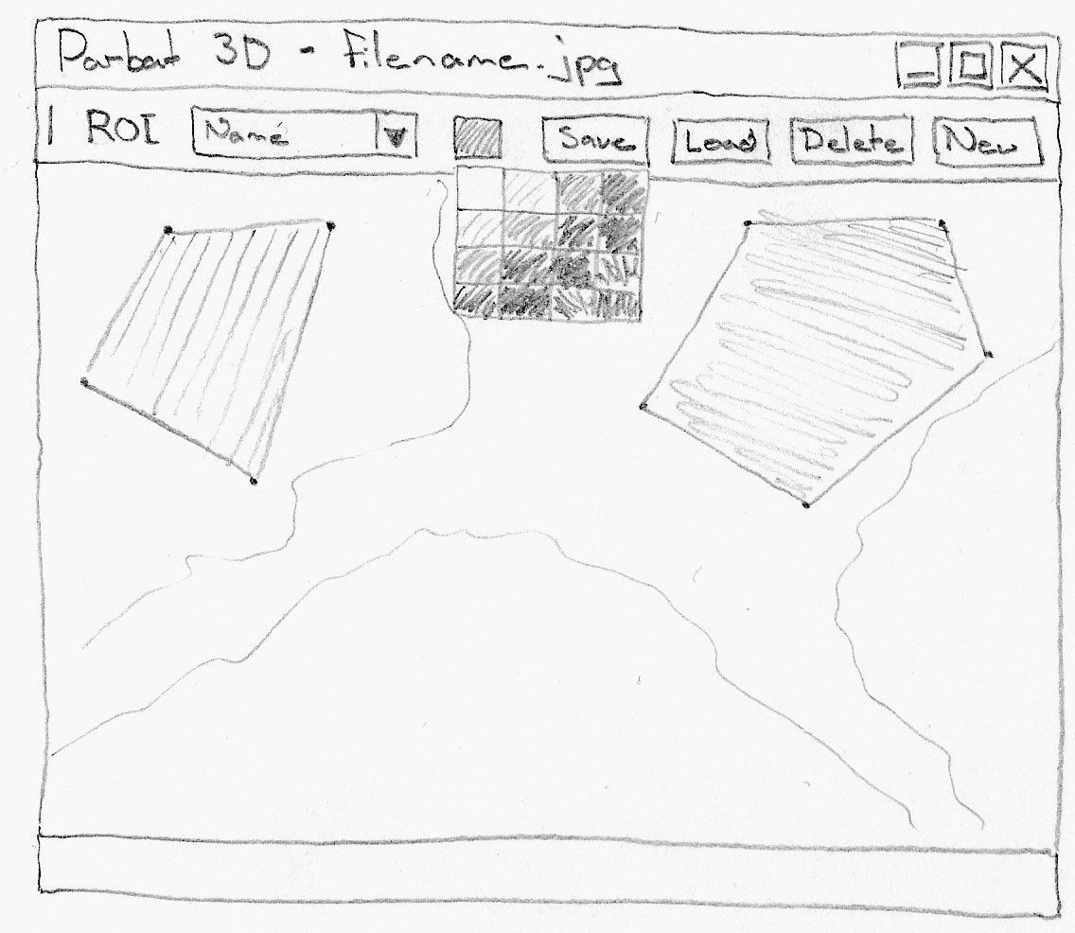

Feedback
Good
- Better incorporation with the image when placing ROI creation toolbar in window.
Improve
- Needs some feedback of which ROI is selected.
Francis Chui (Krill)

Status
Another stage required
Stage 4

Description
- This prototype is accessed via a tab on the Tools window.
- The lower section of the ROI tab is for defining new ROIs.
- To Define a new ROI, the user enters a name and chooses a colour. The ‘Define’ button will become activate. The user then clicks each point of a polygon in the Image window to create a region. To close and complete the region, the first point is clicked again.
- ROIs can be loaded at any time.
- A user can select an existing ROI and click ‘Remove’ to remove it, or ‘Save’ to save it.

Stage | Previous Stage | Developer
4 | None | Dave
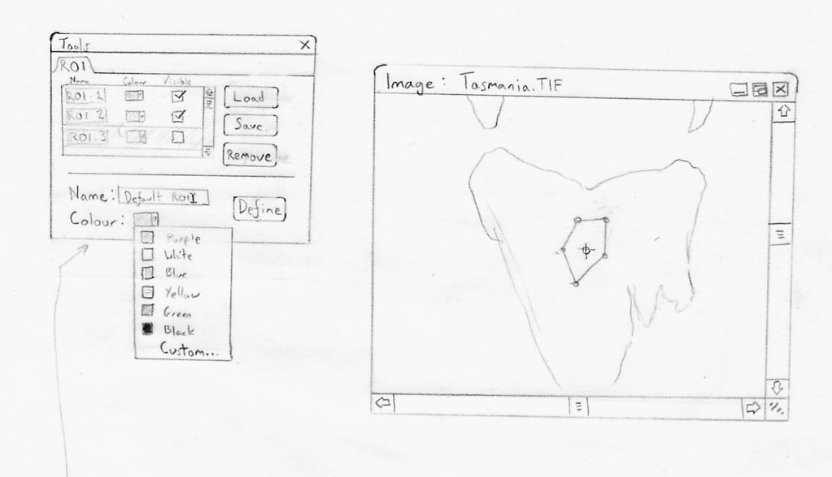

Feedback
Nil

Status
Another stage required
Stage 5

Description
- This prototype is accessed via a tab on the Tools window.
- Upon selecting ‘New’, the ‘save’ and ‘Cancel buttons will become active and the cursor will change to a crosshair.
- Each point is selected with a mouse click. Delete will remove a single point.
- Escape or ‘Cancel’ to will cancel the create ROI operation.
- Upon closing polygon, the user can then select ‘Save’ (standard save window). The ROI will then appear in the list.

Stage | Previous Stage | Developer
5 | None | Damian
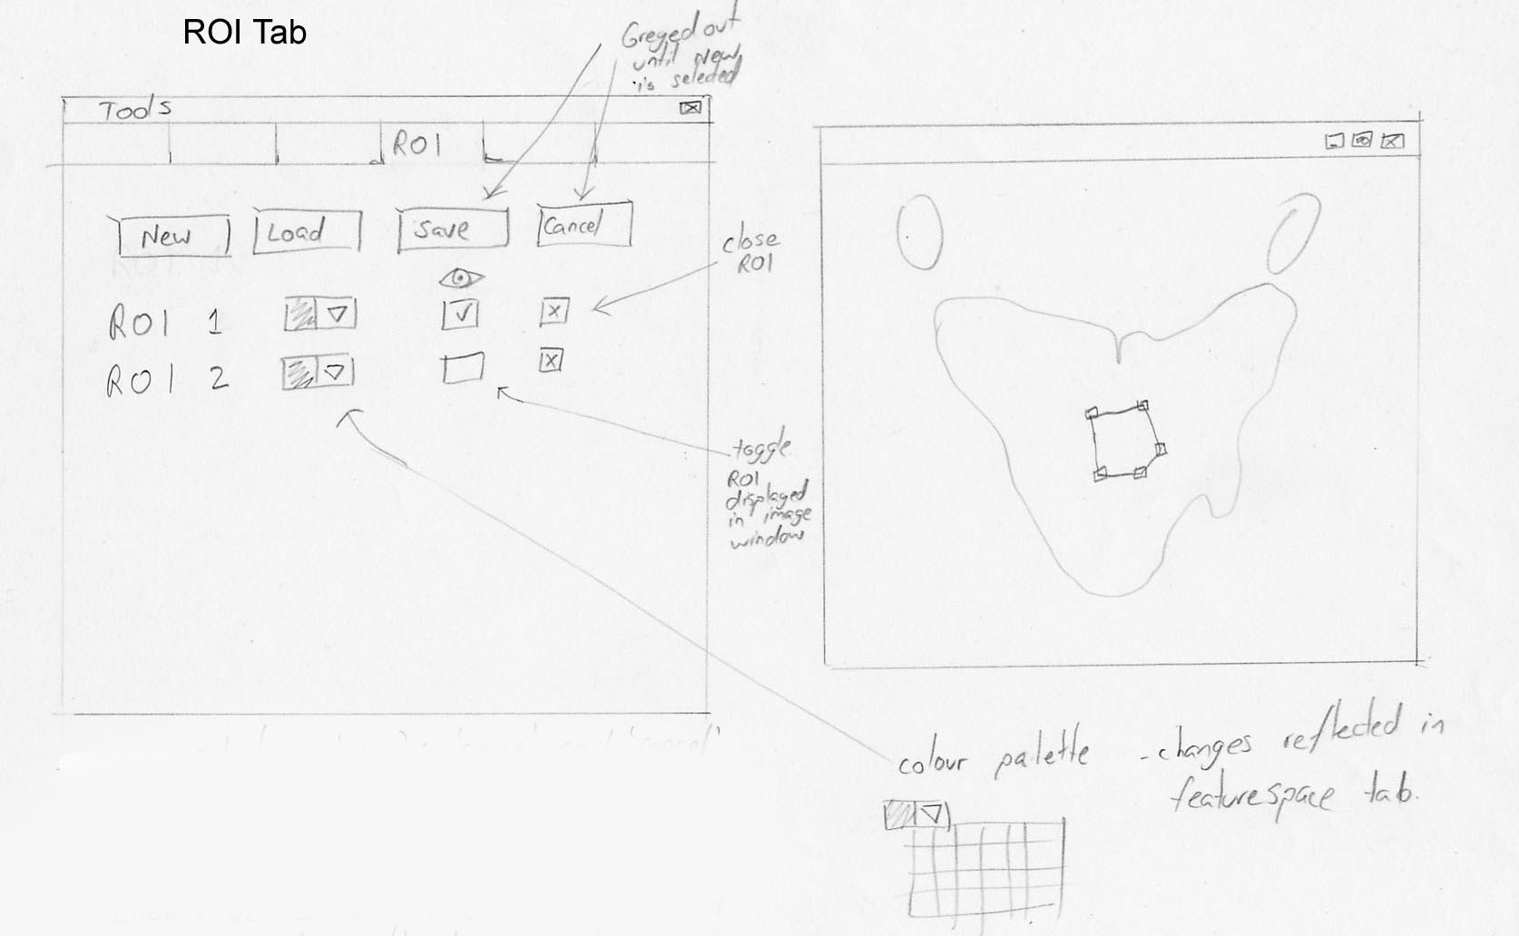

Feedback
Good
- I like how new ROI will be added one after another
Improve
- Having the close/view ROI next to each other would get annoying with accidental clicks.
Francis Chui (Krill)

Status
Another stage required
Stage 6

Description
- This prototype is accessed via the toolbar menu on the Overview window.
- When a new region is created it is added to the list in the ROI window.
- A random colour is assigned to the ROI.
- Visibility of the ROI in the image window is controlled via the checkbox and is enabled by default.
- The colour assigned to the ROI is changed via a dialogue window after double clicking on the colour box.
- The ROI name can be changed by double clicking on it.
- The save button prompts the user to select a file to which selected ROIs can be saved (to our file format).
- The Load button prompts the user to select a file to merge with the current ROI list.
- The Trash button or the Delete key (after conformation) deletes selected ROIs from the list.
- Active ROIs are drawn as outlines in the Image window.
- Other 2 buttons enable creation of ROIs interactively as either rectangular or arbitrarily shaped polygons.

Stage | Previous Stage | Developer
6 | 1, 2, 3, 4 and 5 | Whole Team
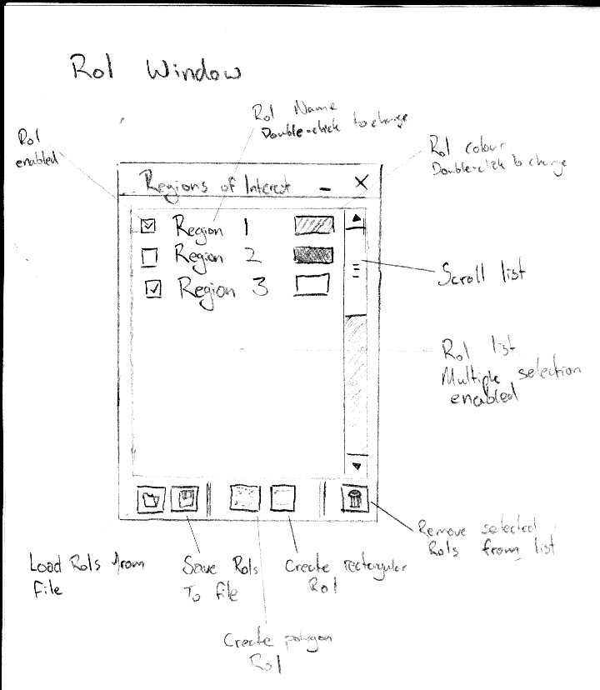

Feedback
Nil

Status
Approved by most people and finished

Feature Space Creation Window
The Feature Space Creation Window is used to set-up and create the Feature Space Window which displays a user defined Scatter Plot. Scatter Plots can be created using the whole image, just the ROIs or the whole image with ROIs highlighted. Each display channel (RGB) can be assigned a band to be displayed in the Scatter Plot.
Stage 1

Description
- This Prototype is accessed via a tab in the Tools window.
- Radio buttons are used for display options.
- ROIs are selected via check boxes.
- Any image band can be assigned to an axis in the scatter plot via radio buttons.
- The create button displays the feature space.

Stage | Previous Stage | Developer
1 | None | Shane
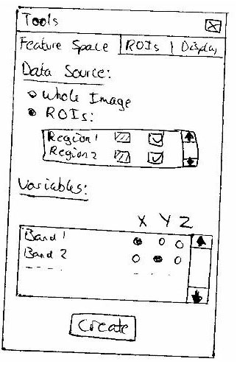

Feedback
Nil

Status
Another stage required
Stage 2

Description
- This prototype is accessed via a tab on the Tools window.
- An axis can be assigned any or no band via radio buttons.
- The check box sets the option to only show active ROIs.
- The granularity is selected via a slide bar and the number of points are displayed accordingly.
- Generate button creates new visualisation window with set (static) configuration.
- Active ROIs (if any) will always be drawn in their preset colour.

Stage | Previous Stage | Developer
2 | None | Rowan
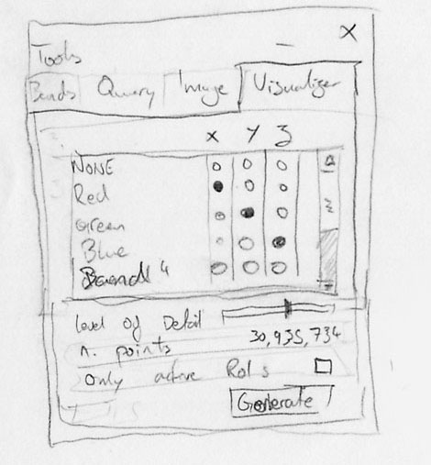

Feedback
Nil

Status
Another stage required
Stage 3

Description
- This prototype is accessed via the toolbar menu on the Overview window.
- Display options are chosen via radio buttons
- Any image band can be assigned to an axis in the scatter plot via radio buttons.
- The create button displays the feature space.

Stage | Previous Stage | Developer
3 | None | Matt
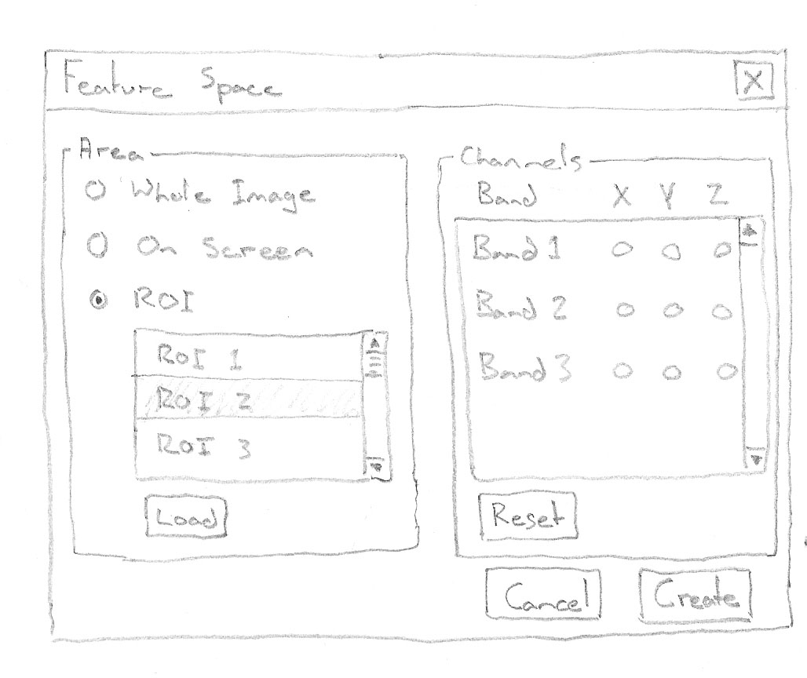

Feedback
Nil

Status
Another stage required
Stage 4

Description
- The Granularity is entered manually via a text field.
- If the ‘Entire image’ checkbox is ticked only, the Scatter Plot will be of the entire image’
- If an ‘ROI’ checkbox (1 or more) is ticked only, the Scatter Plot will be of the selected ROIs only and displayed with selected colours.
- If the ‘Entire Image’ checkbox and an ‘ROIs’ checkbox (1 or more) is ticked, the Scatter Plot will be of the entire image with the ROIs represented by selected colours and the remaining points will be white.
- Bands that are displayed in the image window that are chosen in the Channel Selection tab can be assigned to any or the x, y and z axis.
- ROIs can be assigned an individual colour for the Scatter Plot that differs from that in the Image window.

Stage | Previous Stage | Developer
4 | None | Damian
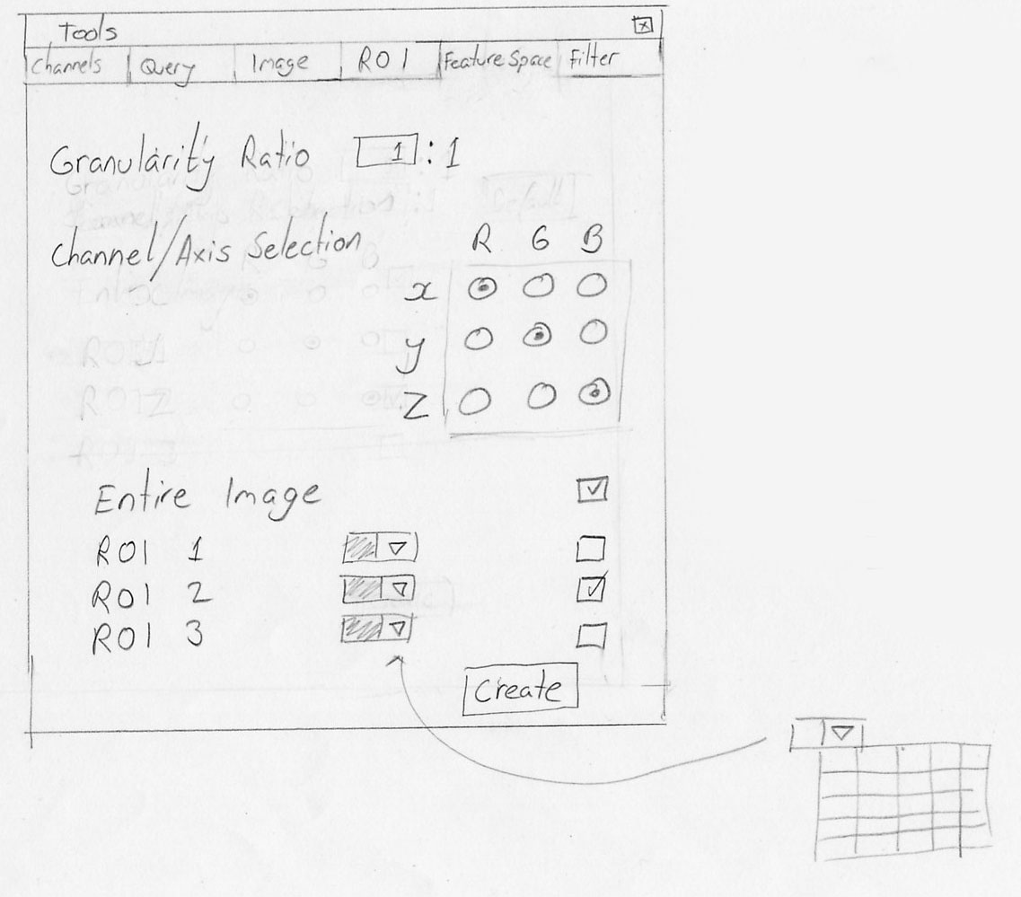

Feedback
Improve
- Tabs seem a little confusing.
- With channel/axis selection.
- Granularity ratio could use a spinner as well as the textbox
Francis Chui (Krill)

Status
Another stage required
Stage 5

Description
- Any image band can be assigned to an axis to be displayed in the Scatter Plot.
- The granularity is set via a slider with preset binary values which in turn updates the number of points value.
- If the Active ROIs checkbox is ticked, the Scatter Plot will display only ROIs that are loaded in the ROI window.
- If the Active ROIs checkbox is unticked, the Scatter Plot will display the entire image with active ROIs that are loaded in the ROI window displayed in their respective colours. If there are no active ROIs, only the entire image will be displayed in the Scatter Plot.

Stage | Previous Stage | Developer
5 | 1, 2, 3 and 4 | Whole Team
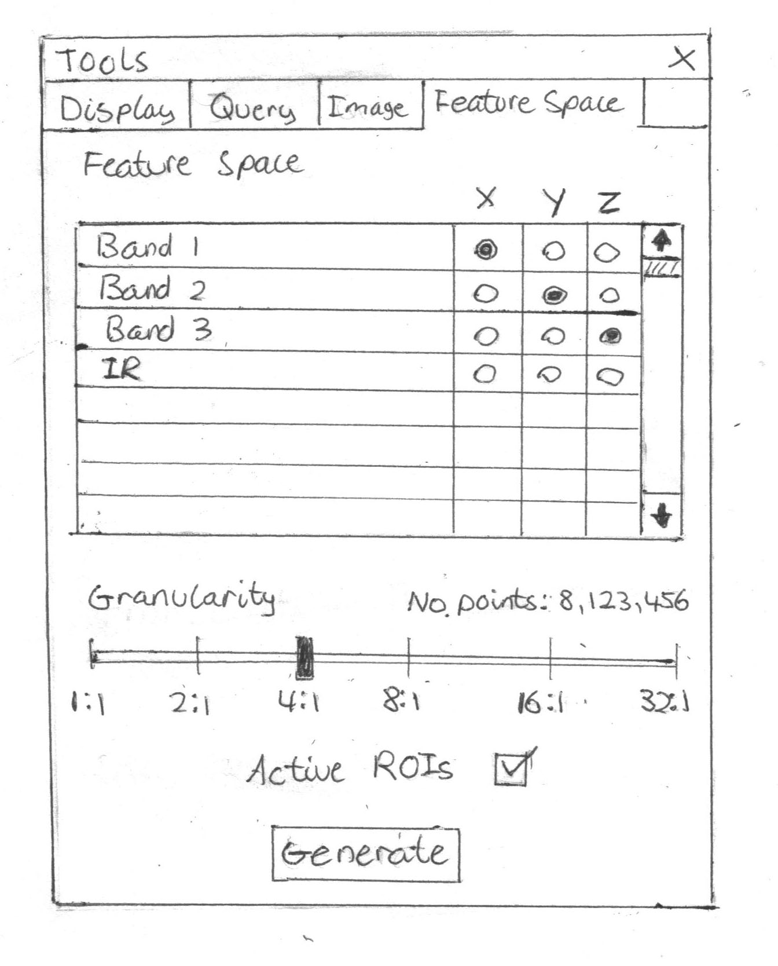

Feedback
Nil

Status
Approved by most people and finished

Feature Space Window
The Feature Space window will display a predefined Scatter Plot. Each point in the Scatter Plot represents the pixel values from chosen image channels along the x, y or z axis. The user will be able to zoom, pan and rotate the Scatter Plot.
Stage 1

Description
- The status bar displays information on what the buttons do when the mouse is moved over them.
- The Feature Space control buttons are Rotate, Left/Right/Up/Down and Zoom in/Zoom out.
- The ROIs highlighted are indicated via an index in the top right corner.

Stage | Previous Stage | Developer
1 | None | Shane
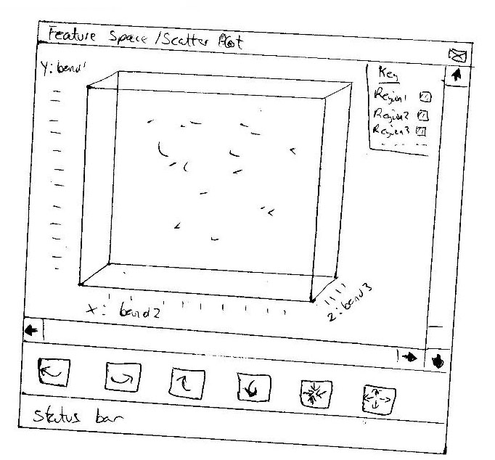

Feedback
Good
- Buttons for control of scatter plot rotation.
Francis Chui (Krill)

Status
Another stage required
Stage 2

Description
- This prototype is accessed via the ‘Generate’ button on the Feature Space Creation tab on the Tools window.
- Bands associated with each axis, the granularity and number of points are displayed in the bottom left corner.
- All navigation controls are accessed via shortcuts or the mouse.

Stage | Previous Stage | Developer
2 | None | Rowan
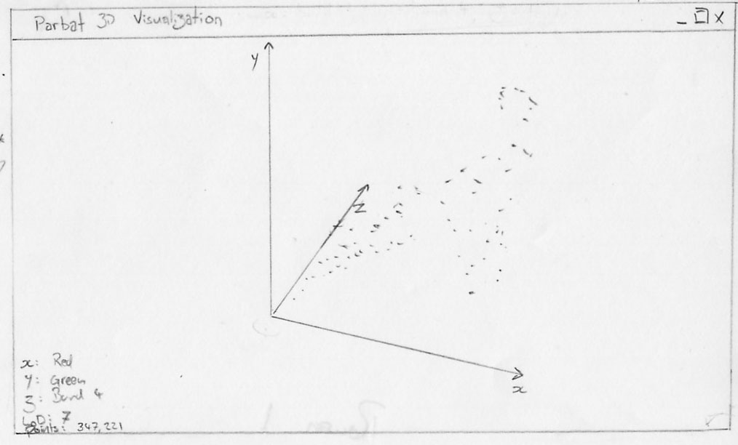

Feedback
Nil

Status
Another stage required
Stage 3

Description
- This prototype is designed to be simplistic.
- It is accessed by pressing the create button on the feature space creation window.
- An axis direction indicator is displayed in the bottom right and rotates as the image is rotated.
- The status bar contains a progress bar for Scatter Plot creation.
- All controls are accessed via shortcuts or the mouse.

Stage | Previous Stage | Developer
3 | None | Matt
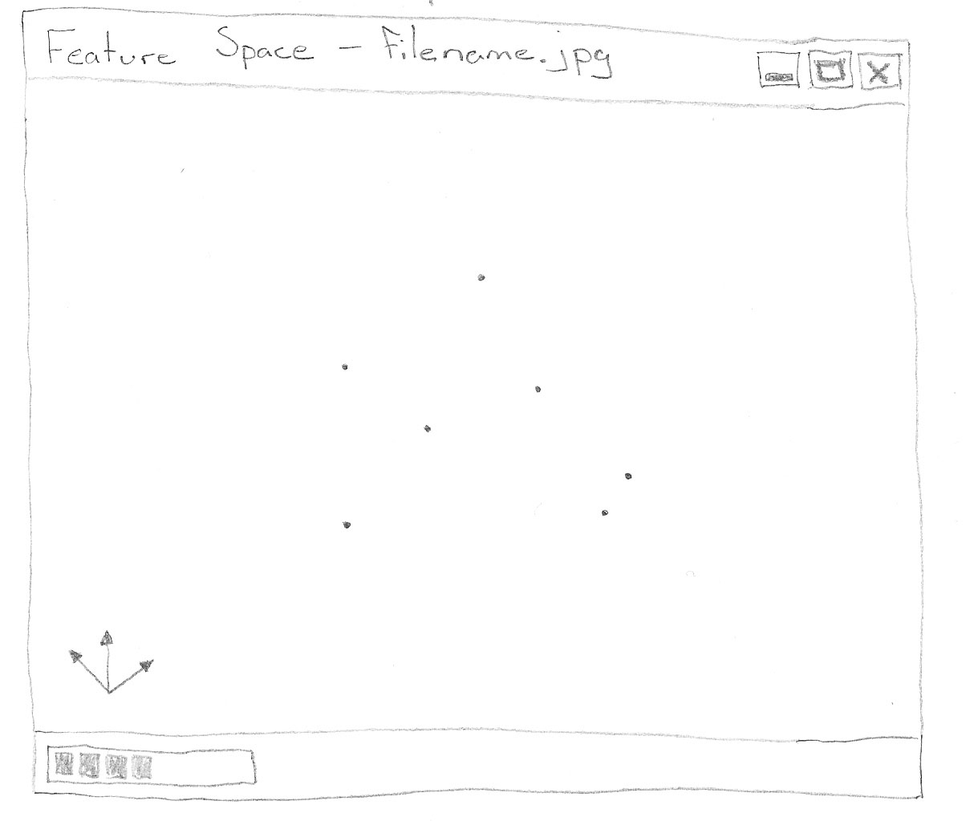

Feedback
Good
- Display of axis is good
Improve
- Will scatter be able to be rotated? If origin is the centre would get confusing with axis off centre when that spins as well.
- A bounding box like Damian's design would help.
Francis Chui (Krill)

Status
Another stage required
Stage 4

Description
- This prototype is accessed via the ‘Create’ button on the Feature Space Creation tab on the Tools window.
- Bands associated with each axis are displayed in the top left corner.
- Navigation controls are Rotate left and right, Rotate up and down, Pan in any direction, Zoom in and Zoom out.
- For the Rotate and Zoom buttons, the user simply clicks and holds on the button and drags in the appropriate direction.
- The granularity is displayed in the right of the status bar.

Stage | Previous Stage | Developer
4 | None | Dave
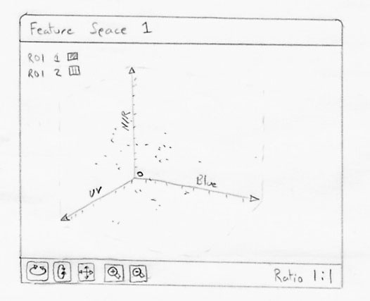

Feedback
Nil

Status
Another stage required
Stage 5

Description
- The ROI index that is displayed in the top left can be toggled on and off in the status bar.
- The granularity of the Scatter Plot can be updated via the status bar.
- The scroll wheel on the mouse will zoom in and out.
- To rotate in any direction the user must left click the mouse and drag in the appropriate direction.
- To pan in any direction the user must right click the mouse and drag in the appropriate direction.

Stage | Previous Stage | Developer
5 | None | Damian
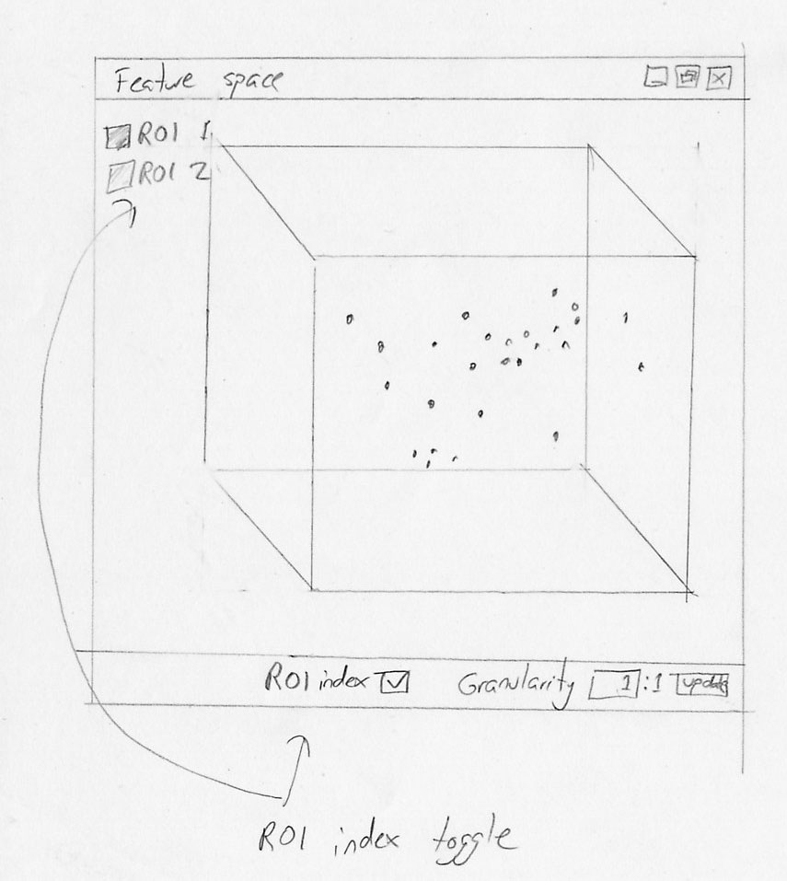

Feedback
Good
- Simple and well laid out window
Improve
- Depth cue for scatter plot with the use of brightness variation with depth. This would allow the user to view location of a point without constant spinning of the plot (point relative to surrounding).
Francis Chui (Krill)

Status
Another stage required
Stage 6

Description
- This prototype is accessed via the generate button on the Feature Space Creation tab on the Tools window.
- The window will open and the progress bar will visually show how long until the Scatter Plot is loaded.
- The ROI index that is displayed in the top left can be toggled on and off in the status bar.
- The scroll wheel on the mouse and 2 of the buttons on the status bar will zoom in and out.
- The arrow buttons on the status bar will rotate the Scatter Plot in any direction.
- To pan in any direction the user must left click the mouse and drag in the appropriate direction.
- In the very right of the status bar are 3 options for displaying a Bounding Cube, 3 way Axis or Nothing around the Scatter Plot.

Stage | Previous Stage | Developer
5 | 1, 2, 3, 4 and 5 | Whole Team
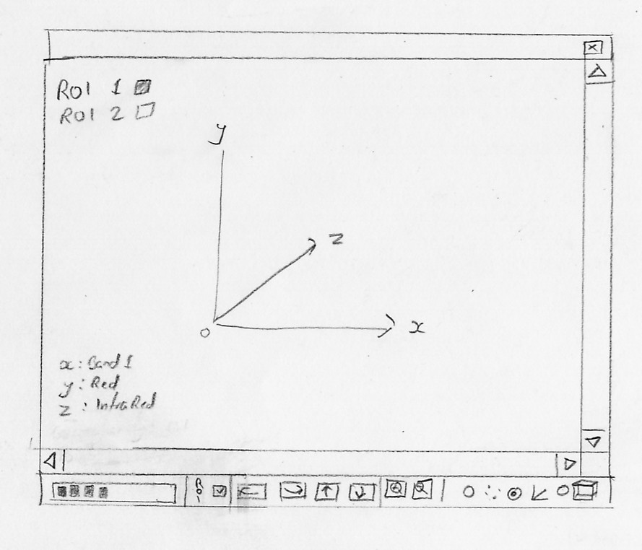

Feedback
Nil

Status
Approved by most people and finished

3D Visualisation of Satellite Imagery
Release Schedule
Team Imagery
Damian Brockie
Rowan James
Shane Kingston
Matthew McKellar-Spence
Dafydd Williams

Release 1
The first release of this software encompassed the Graphical User Interface and is a stand-alone application. The application was written for the Microsoft Windows XP platform.

Graphical User Interface
The Graphical User Interface consists of multiple windows, namely a main Overview window, an Image window and a Tools window. The Overview window consists of a thumbnail of the entire image and the file menu. The Image window displays the image at a user defined zoom level and pan. The Tools window contains several tabs, namely a Display tab, a Query tab and an Image tab. The Display tab contains radio buttons for matching Image bands to the RGB colours they are to be displayed in and a corresponding up-date button. The Query tab displays the values of the image bands represented by a pixel in the main viewing window along with the x and y coordinates. The Image tab contains information about the file, namely the file name, the file type, image width, image height and number of bands.

Image File Management
The Application has the ability to load and analyse images of an arbitrarily large size in the JPEG 2000, GeoTIFF, ECW and standard JPEG file formats.

Functionality
The user has the ability to arrange all windows and the application will remember the window locations upon start-up. The windows can be dock with each other and when the Overview window is moved, the adjoining docked windows will move too. Minimising the Overview window minimises all windows. When the Display window is maximised, other windows will remain on top. The Overview window is the only window to appear when the application is loaded and upon opening an image the other windows will appear and can be toggled off and on again from the file menu.
Each colour channel (RGB) can represent a spectral band from the image. This can be assigned in the Display tab of the Tools. The Image Window has the ability to be panned and zoomed. The Query tab in the Tools window has the ability to display the values of the channels represented by a pixel in the Image window and updates as the mouse cursor moves from one pixel to the next in the Image window.

Release 2
The second release of this project will include all of the features that we believe can be completed within the time available. These features include 3D graphics and more user control.

Graphical User Interface
The graphical user interface of this release will be extended to include the ability to use shortcut keys for zooming, panning and applying filters (if available), along with other similar commands. The user will able to select areas of the image using the mouse in a similar way to the “Polygonal Lasso” tool that is available in Adobe Photoshop. Multiple, non-contiguous areas of an image will be able to be selected at the same time. The program will have the ability to record these selections as Regions Of Interest (ROIs). The user will be able to save and load these ROIs to and from files on a disk.

Image File Management
The user will also have the ability to save the image, or a section of it, after filtering and classification operations have been performed (if they are available).

3D Feature Space
The application will display a feature space (scatter plot), in either two or three dimensions, from the spectral bands that have been chosen by the user. The data for this scatter plot will be based from either the whole image or 1 or more ROIs. The 3D feature space will be represented as a 3D cube. It will be able to scale the granularity of the pixel data, from a 1:1 ratio of one pixel per point in the scatter plot, and thereafter one point in the feature space may represent a number of pixels in the image.

Extra Display Features
The application will allow pixels that are encompassed by ROIs in the main image window to be correspondingly highlighted in the feature space plot, displaying the entire image. The user will be able to define colours for ROIs in the main image window and these colours will also be shown in the feature space plot for the pixels that correspond with those ROIs.

Operations
The channel management system of the application will have common operations such as image normalizing and contrast enhancement embedded into it. These common operations will be computed “on the fly”, and apply only to the display, such that they will not change the original image data, or the data that will be used for mathematical or statistical operations.

Release 3
Features for release 3 will only be implemented if time permits.

Feature Space
Pixel selections and ROIs in the main window shall be highlighted in the feature space. Points shall be able to be selected in the feature space, with the corresponding pixels in the main window being highlighted. ROIs in the main window shall be shown in the feature space by surrounding the points in an Isosurface. These Isosurfaces shall then be able to be selected, with the corresponding ROIs being highlighted in the main window. The user shall be able to select an entire region of points in the visualisation, or all points near the currently selected one within a given threshold of one or more of its properties.

Plug-ins
The application shall allow 3rd party plug-ins, such as custom or advanced filters, to be added and have image data exported to them for processing. Initially the application may only accept Java plug-ins, but if possible, other plug-ins interface languages such as Python and IDL may be implemented. Example plug-ins shall be provided for operations such as land cover classification and edge enhancement.

Digital Elevation Model
The application shall allow the user to fly over the image, which has been draped over a DEM, in real-time. The DEM information will be in a separate file to the imagery and will have to be provided by the user.

Platform
An X11 interface shall be created, to allow use on platforms such as Mac OS X, and Unix variants like Linux, BSD, IRIX, or Solaris.

3D Visualisation of Satellite Imagery
Text File Report
Team Imagery
Damian Brockie
Rowan James
Shane Kingston
Matthew McKellar-Spence
Dafydd Williams

ROI Definition File
One of the requirements for Parbat3D Release 2 is to be able to save and load Regions Of Interests (ROIs) to and from a file. This report documents the format of the file that will be used by the program in order to represent the ROIs.

General File Format
The data will be stored in a plain ASCII text based format that is compatible with standard Microsoft Windows .ini information files. This format consists of multiple named sections with each containing a number of named fields and values.

Sections
The start of a section is defined by a line that contains the name of the section inside square brackets. An example of a section definition is shown on the following line:
[SectionName]

Fields and values
The fields and values that are related to a section are listed underneath the section definition line, with a single field and value on each line. Each field line consists of a field name, followed by an equal sign, followed by the value of the field. The value of a field can be represented as a single or multiple word strings, a number or a comma separated list of numbers or strings.

Example:
myField=some value
myField=this
myField=20
myField=20,31
myField=one,two,three

ROI File Sections, Fields and Values
The ROI definition file may contain one or more definitions of Regions Of Interests for a particular image. For each ROI we need to record a name, a sequence of (X,Y) points and a colour. This information will be recorded in separate ‘[ROI]’ sections of the file, with each section being associated with a single ROI. The ‘[ROI]’ section contains the following fields and values:

The ‘name’ field will be a single or multiple word string containing the name of the ROI.

The ‘points’ field will contain a comma separated list of numbers representing the sequence of (X,Y) point that defines the ROI, where the first number represents the X co-ordinate of the first point, the second the Y co-ordinate of the first point, the third the X co-ordinate of the second point, the fourth the Y co-ordinate of the second point, etc.

The ‘colour’ field will contain a single string starting with a ‘#’ symbol followed by six hexadecimal digits which represent the RGB colour in the format of ‘#RRGGBB’, where ‘RR’ is the red component, ‘GG’ is the green component and ‘BB’ is the blue component.

In order to give users some knowledge about which image is associated with a set of ROIs and to try to prevent the user from attempting to load ROIs that are associated with a different image, the ROI definition file will also contain information about the image that is associated with the ROIs. This information will be contained in an ‘[Image]’ section of the file. The ‘[Image]’ section will contain the following fields:

The ‘filename’ field will contain the name of the image file (without including the directory that is was stored in).

The ‘width’ field will contain a number that identifies the width of the image in pixels.

The ‘height’ field will contain a number that identifies the height of the image in pixels.

Example:
[Image]
filename=image.jpg
width=1000
height=800
[ROI]
name=Region1
points=0,3,2,1,4,3,5
color=#FF0000
[ROI]
name=Region2
points=130,243,352,241,453,454
color=#0000FF

In the example above, the first ROI has the points (0,3), (2,1), (3,5) and the colour red. The second ROI has the points (130,243), (352,241), (453,454) and the colour blue.

